Farhad Ramezanghorbani 20131758 – HW9

In AX = B:
X is matrix of forces from f1 to f13
A is matrix of coefficient
B is matrix of constant

A:
[[ 0. 1. 0. 0. 0. -1. 0. 0. 0. 0. 0. 0. 0.]
[ 0. 0. 1. 0. 0. 0. 0. 0. 0. 0. 0. 0. 0.]
[ 0.7071 0. 0. -1. -0.7071 0. 0. 0. 0. 0. 0. 0. 0.]
[ 0.7071 0. 1. 0. 0.7071 0. 0. 0. 0. 0. 0. 0. 0.]
[ 0. 0. 0. 1. 0. 0. 0. -1. 0. 0. 0. 0. 0.]
[ 0. 0. 0. 0. 0. 0. 1. 0. 0. 0. 0. 0. 0.]
[ 0. 0. 0. 0. 0.7071 1. 0. 0. -0.7071 -1. 0. 0. 0.]
[ 0. 0. 0. 0. 0.7071 0. 1. 0. 0.7071 0. 0. 0. 0.]
[ 0. 0. 0. 0. 0. 0. 0. 0. 0. 1. 0. 0. -1.]
[ 0. 0. 0. 0. 0. 0. 0. 0. 0. 0. 1. 0. 0.]
[ 0. 0. 0. 0. 0. 0. 0. 1. 0.7071 0. 0. -0.7071 0.]
[ 0. 0. 0. 0. 0. 0. 0. 0. 0.7071 0. 1. 0.7071 0.]
[ 0. 0. 0. 0. 0. 0. 0. 0. 0. 0. 0. 0.7071 1.]]

B:
[[ 0]
[10]
[ 0]
[ 0]
[ 0]
[ 0]
[ 0]
[15]
[ 0]
[20]
[ 0]
[ 0]
[ 0]]

X:
[[-28.2845425 ]
[ 20. ]
[ 10. ]
[-30. ]
[ 14.14227125]
[ 20. ]
[ 0. ]
[-30. ]
[ 7.07113562]
[ 25. ]
[ 20. ]
[-35.35567812]
[ 25. ]]

Part two results:
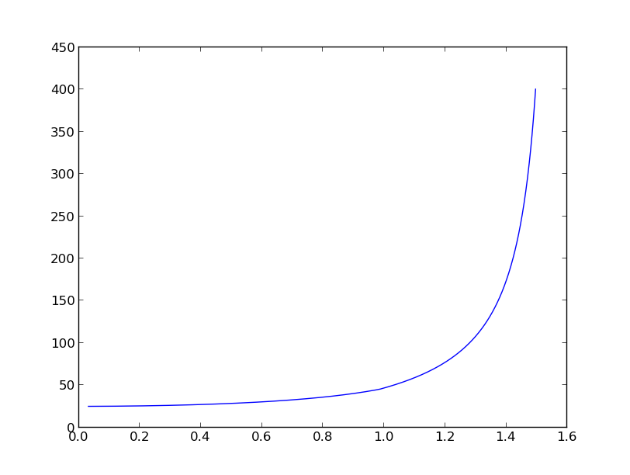
horizontal axes: angle (1-3-2) - rad
vertical axes: maximum force in truss

In part one: with solve() function – which provides a linear solution for Ax = B, we can obtain X elements which are forces (f1 to f13).
In the second part of question, we cannot see optimum in 45 degree. If we decrease the 1-3-2 angle from 90 degree to zero or truss will be shaped vertically and in that case we can approximately say that 1 and 2, also 8 and 7 are the same, and maximum force goes to a constant value near alpha = 0.

for alpha values near 90, truss shape would be horizontal, and it make sense to have an infinite value for maximum force of the truss.

from math import *
from numpy import *
import pylab as pl
from numpy.linalg import *

####################################### coefficient matrix of forces:
A=matrix('0 1 0 0 0 -1 0 0 0 0 0 0 0 ; 0 0 1 0 0 0 0 0 0 0 0 0 0 ; 0.7071 0 0 -1 -0.7071 0 0 0 0 0 0 0 0 ; 0.7071 0 1 0 0.7071 0 0 0 0 0 0 0 0 ; 0 0 0 1 0 0 0 -1 0 0 0 0 0 ; 0 0 0 0 0 0 1 0 0 0 0 0 0 ; 0 0 0 0 0.7071 1 0 0 -0.7071 -1 0 0 0 ; 0 0 0 0 0.7071 0 1 0 0.7071 0 0 0 0 ; 0 0 0 0 0 0 0 0 0 1 0 0 -1 ; 0 0 0 0 0 0 0 0 0 0 1 0 0 ; 0 0 0 0 0 0 0 1 0.7071 0 0 -0.7071 0 ; 0 0 0 0 0 0 0 0 0.7071 0 1 0.7071 0 ; 0 0 0 0 0 0 0 0 0 0 0 0.7071 1')
####################################### constant matrix in AX = B:
B=matrix('0 ; 10 ; 0 ; 0 ; 0 ; 0 ; 0 ; 15 ; 0 ; 20 ; 0 ; 0 ; 0')
############################################ soloution of AX = B:
x = solve(A,B)
print "fi values for i in [1,13]\n", x
##############################################################
n = linspace(pi/100,pi/2.1,1000) #list of 1000 number in [pi/100,pi/2.1]

List = []
for t in n: #change alpha in coefficient matrix
#considering the angle of 1-3-2
A[2,0] = sin(t)
A[2,4] = -sin(t)

A[3,0] = cos(t)
A[3,4] = cos(t)

A[6,4] = sin(t)
A[6,8] = -sin(t)

A[7,4] = cos(t)
A[7,8] = cos(t)

A[10,8] = sin(t)
A[10,11] = -sin(t)

A[11,8] = cos(t)
A[11,11] = cos(t)

A[12,11] = sin(t)

y = solve(A,B)
List.append(abs(y).max())

pl.plot(n,List)
pl.show()

